**Tour Newyork - Losangeles - Lasvegas 10 Days 9 Nights**

*Attention:*

-Departure: Hanoi.

-Time: 10 days 9 nights.

-Transport: aircraft.

-Tour price: 65900000đ.

-Image:

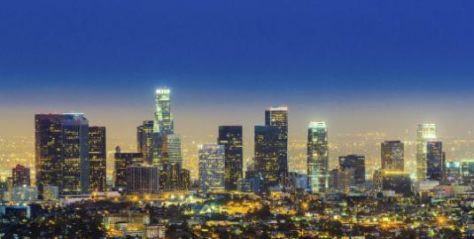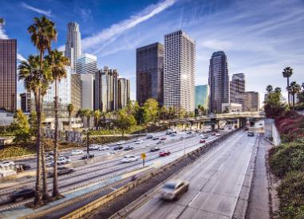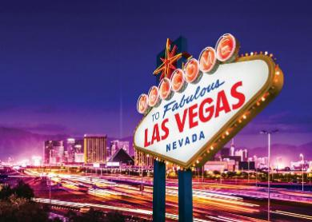

**I.Introduce:**

**AMERICAN TRAVEL**

**Travel America - Travel the United States - a vast country that includes 50 states and a federal district. The capital of the United States is Washington DC between North America and the largest city in the United States is New York. This vast country has many beautiful and poetic landscapes, and many interesting mysteries you should uncover.**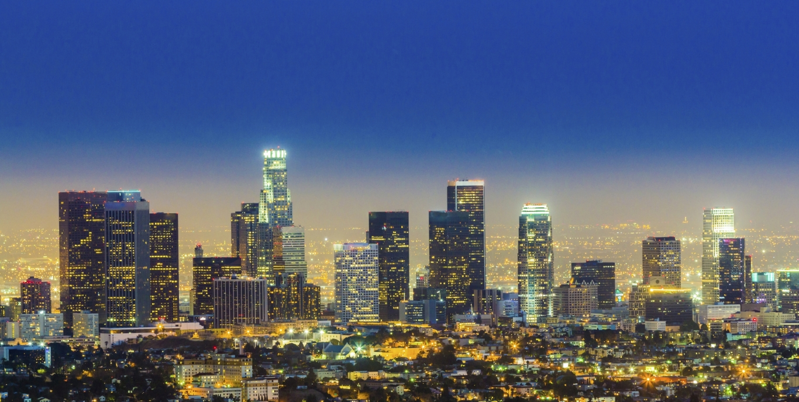

Not only attracted to the beautiful natural landscapes of a miniature world, the United States is also a place of convergence of diverse cultural identity, a major center of the world, so the United States also Dubbed the "Land of Heaven", where everyone in the world aspires to set foot once in a lifetime.

**II.Tour schedule:**

**1.DAY 1:**

**HaNoI - NEW YORK**

_____________________________________________________________________

Vietcenter's car and guide pick you up at the meeting place, depart for Noi Bai airport. You check in for a flight to Taipei. Arriving in Taipei, the Group continued connecting flights to New York. Eating on the plane.

By crossing the route to change the date, the delegation to New York the same day of departure. You do entry procedures. Have dinner. Pick up and take you to the hotel to rest. _____________________________________________________________________

**2.DAY 2:**

**NEW YORK**

_____________________________________________________________________

Breakfast - Noon - Evening

After breakfast at the hotel, depart to visit New York City with famous landmarks Statue of Liberty - Symbol of America. Point 0, also known as Ground Zero - Ruins of the World Trade Center after September 11 event. Wall Street Financial Street - The location of the New York Stock Exchange and the financial and banking centers . It is also considered the financial center of the world. Every movement of Wall Street affects the global financial situation. United Nations Headquarters (United Nation) - The workplace of the UN Security Council and the other councils of the United Nations organization. Lunch at Vietnamese restaurant.

You visit the Rockerfeller Center - busy shopping center, where the headquarters of NBC TV channel, where the focus of expensive brand shops. 5th Avenue Fifth Avenue - The fashion center of the United States, where the focus of the Catwalk and fashion brands of the world. Time Square - Square in downtown New York is dazzling with colored lights and billboards. This is where the mayor of the city speaks in public and holds major New York events. Group dinner at local restaurant and rest at hotel. _____________________________________________________________________

**3.DAY 3:**

**NEW YORK - PHILADENPHIA - WASHINGTON D.C**

_____________________________________________________________________

**Breakfast - Noon - Evening**

After breakfast at the hotel, check out hotel and depart for Philadelphia. The car takes you to the south of the journey through the states of New Jersey, Delaware, Baltimore, Pennsylvania. Arrive in Philadelphia, the delegation stopped to take a photo: The US coin mint. Visiting the Bell of Freedom - This is the bell that beats the bell of birth of America. Previously the bell was placed on the tower of Independence Palace. Now this historic bell is kept in a separate museum in Philadelphia every year with over 10 million visitors, including heads of state. Visit Independence Palace (Independence Hall) - Currently the building is preserved intact, previously this place held a meeting of 13 states unification of the United States and is a place where very important historic events of early birth of the United States. It is also the headquarters of the US Congressional Congress in its infancy. Lunch break continues to depart for Washington D.C. To Washington D.C. Group dinner at Vietnamese restaurant and return to the hotel to rest. _____________________________________________________________________

**4.DAY 4:**

**WASHINGTON D.C - LOS ANGELES**

_____________________________________________________________________

Breakfast - Noon - Evening

After breakfast, the delegation will check out the hotel and depart to visit the White House (taking photos outside) - The workplace of the current US president, where the heads of state are welcomed. Capitol - United States bicameral building, a unique architectural design. It is a powerful counterweight to the White House, together with the Supreme Court to create a power cauldron of power in the US "Three Right of Separation" political institution. Jefferson Memorial Hall - 3rd President of the United States, who drafted the famous Declaration of Independence of the United States. The ideas in the declaration made by Jefferson were repeated in many independent declarations of other countries including Vietnam. Memorial Hall of Lincoln - The most talented President of the United States, who has helped slavery and unify 36 states of the United States.

group lunch at local restaurant. Then continue the tour: Memorial Memorial Park of the dead soldiers in the United States in the two wars in Vietnam and South North Korea. Washington Monument (photographed from outside) - The first President of the United States, who read the Declaration of Birth of America, a talented general. American Museum of Air and Space - A place to record the development history of the aviation industry, displaying fighter aircraft and civil aircraft in the development order. Here you will go through each stage of development of the aerospace industry of the United States and the world. Bus tour to have dinner at local restaurant. After dinner, the delegation to the airport for the evening flight to Los Angeles (about 6h flight). _____________________________________________________________________

**5.DAY 5:**

**LOS ANGELES - LAS VEGAS**

_____________________________________________________________________

Breakfast - Noon - Evening

After breakfast, check out hotel and depart for Las Vegas by car (about 4 hours). You have the opportunity to shop at Tanger Outlet Factory, where you can buy branded items at surprisingly low prices.

Lunch at the shopping area, then continue the journey to Las Vegas. To Las Vegas, check in hotel and rest. Bus transfer for dinner. You depart to visit the monumental architecture, modern and the largest in the world: New York - New York, MGM, Tropicana, Paris Paris, Mote Carlo, Treasure Island ... You visit the Flower Garden in Guest Bellagio hotel, visit the canals of the Venetian hotel that simulates the floating city of Venice, watch the bright lights can be seen from 40km away from the top of Luxur hotel ... See the Show of pirates, volcanoes, music country. You have the opportunity to try your luck at the largest casino in the world. In addition, you also have the opportunity to enjoy the spectacular Show Jubille (self-sufficient ticket, ticket price: 100usd and must be registered in advance). Return to the hotel to rest.

_____________________________________________________________________

**6.DAY 6:**

**LAS VEGAS**

_____________________________________________________________________

Breakfast - Noon - Evening

Have breakfast at Hotel. You depart to visit the largest Hoover hydroelectric dam in the United States and the largest artificial lake in the world Lake Mead. It is a hydroelectric dam that supplies electricity to both the state of Neveda and irrigation to 7 western states of the United States. Back to Las Vegas for lunch and free shopping for brand goods at the largest outlet factory in the city.

In the evening, you are free to enjoy the special night show: "Le Reve" at Wynn with hundreds of female dancers who are also professional diving athletes appearing backwards on the water (self-sufficient tickets over $ 175) and must register in advance), or Show "O" at Bellagio (self-sufficient tickets, fares depending on time), ... or you can freely explore Las Vegas at night.

_____________________________________________________________________

**7.DAY 7:**

**LOS ANGELES - LAS VEGAS**

_____________________________________________________________________

Check out hotel and depart for Los Angeles. Lunch to Los Angeles and lunch at the restaurant. You visit and shop the US vitamins at the factory.

Visit the commercial center Phuoc - Loc - Tho in Little Saigon. Dinner and check in hotel to rest. _____________________________________________________________________

**8.DAY 8:**

**HOLLYWOOD - TAIPEI**

_____________________________________________________________________

Breakfast - Noon - Evening

After breakfast, depart for Beverly Hill - where the splendid apartments of the stars in the American entertainment industry and expensive fashion shops are located. Visit the Walk of Fame (Hollywood Walk of Fame) - where the list of famous stars who have made great contributions in the village of film, television, music of the United States. Visit Kodak Theater - where the prestigious Oascar Awards ceremony takes place every year in the US film industry. Visit the Chinese Theater - where the premiere introduces Hollywood movies before hitting the market. Lunch at the restaurant.

Afternoon visit to Universal Studios: Watch the Ghost House, Shrek 4-dimensional film, Tram ride to see the whole scene of the film studio, the birthplace of famous movies ... enjoy the excerpt "Under Water World", You self by participating in the sensory games: "Mummy Revenge, Waterfall, ...". Dinner at local restaurant. Bus transfer to airport for flight to Vietnam. You can stay to visit your relatives for the duration of the visa allowed. _____________________________________________________________________

**9.DAY 9:**

**ON THE PLANE** _____________________________________________________________________

You eat and sleep on the plane. _____________________________________________________________________

**10.DAY 10:**

**TAIPEI – HANOI**

_____________________________________________________________________

You transfer aircraft in Taipei to Hanoi. Arrive at Noi Bai airport, the bus will pick you up at the original meeting place. End of tour. _____________________________________________________________________

**III.INCLUDED AND TERMS:**

**Service includes**

* Return flight.
* Cars pick up, see off on the tour.
* 3 star hotel.
* Eat meals according to the program.
* Visa enters the United States.
* Sightseeing tour according to the program.
* Enthusiastic tour guide, fun.
* Drinking water (01 bottle of 0.5l / person / day)
* Travel insurance

Tax V.A.T

**Service not included**

* Personal expenses (Laundry, drinks at meals, phones ...)
* Fostering guides, drivers, hotel staff.

Other expenses not included in the program.